Course Name | ITD 2343 – Object Oriented Programming with C#
Instructor | Mark L. Pranger
Student Name | Lauren Lashley
Due date | February 1, 2026
Grade | <grade earned here>
Grading Comments | <instructor comments here>
Lab Portion of the Section 1 Exam

Screenshot 1:
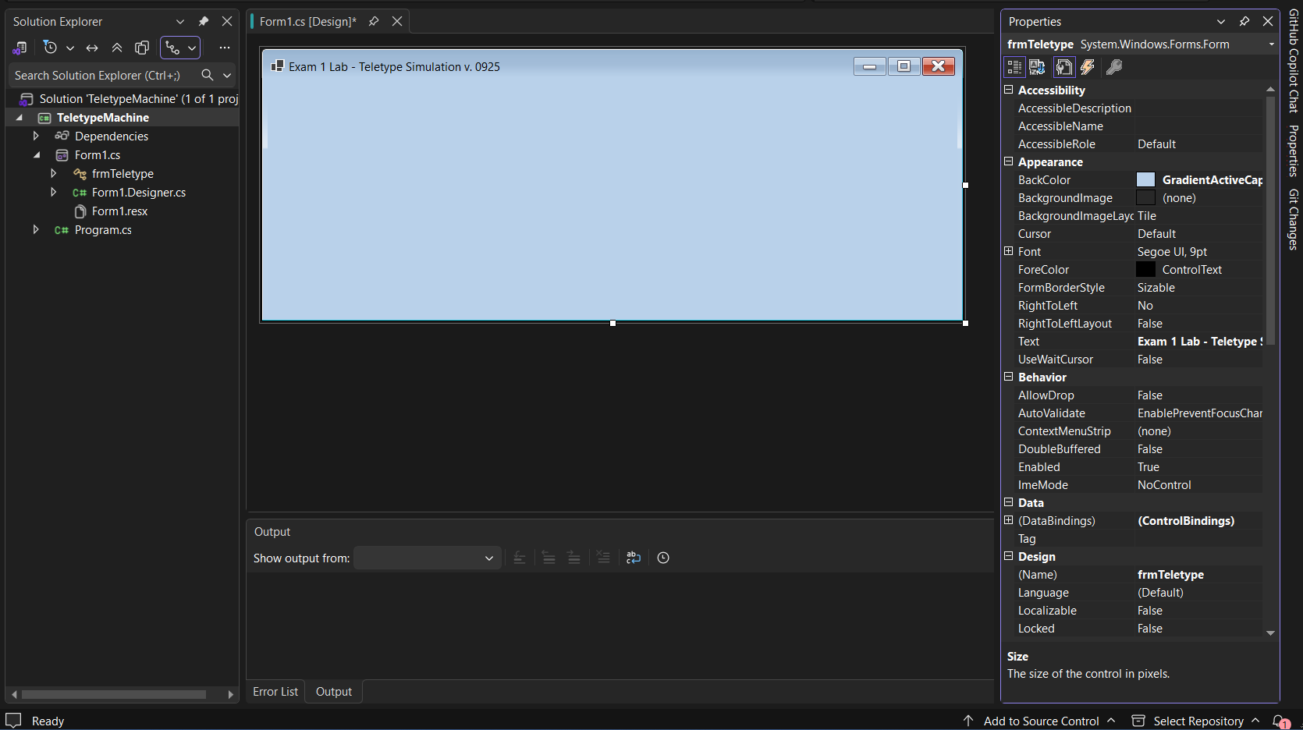

Screenshot 2:
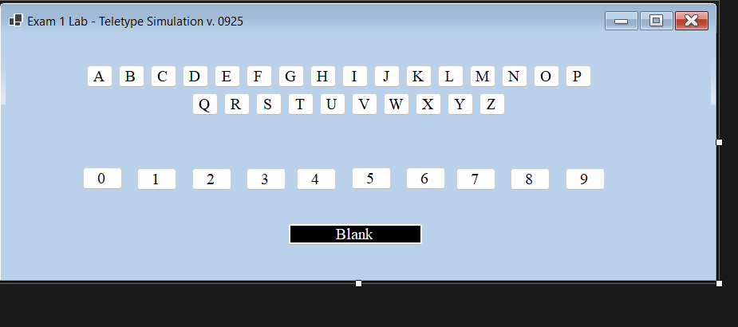

Screenshot 3:
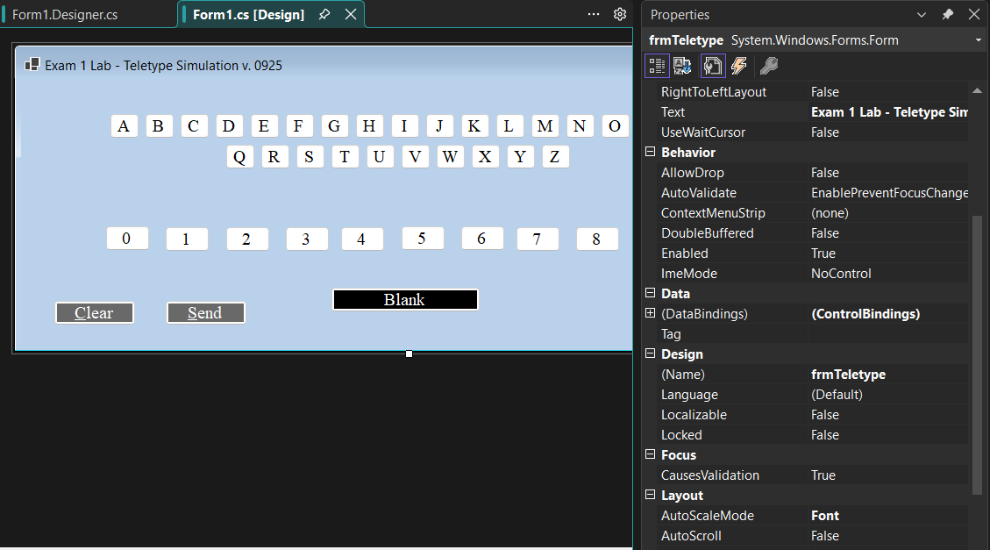

Screenshot 4:
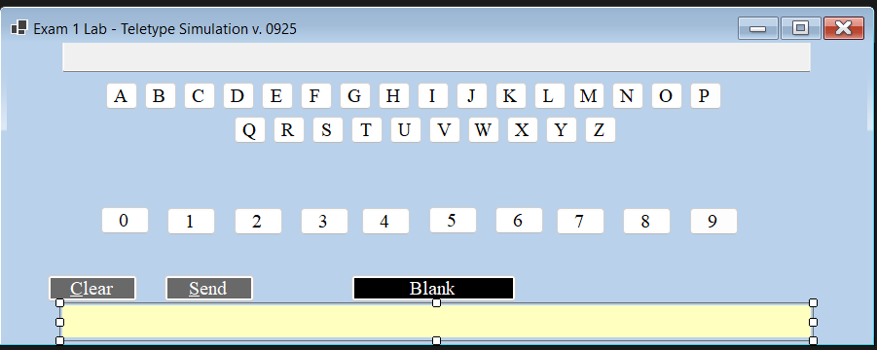

Code running and working:
